21 May

Python Basic - 2

Q.1. Create two int type variables, apply addition, subtraction, division and multiplications

and store the results in variables. Then print the data in the following format by calling the

variables:

First variable is __ & second variable is __.

Addition: __ + __ = __

Subtraction: __ - __ = __

Multiplication: __ * __ = __

Division: __ / __ = __

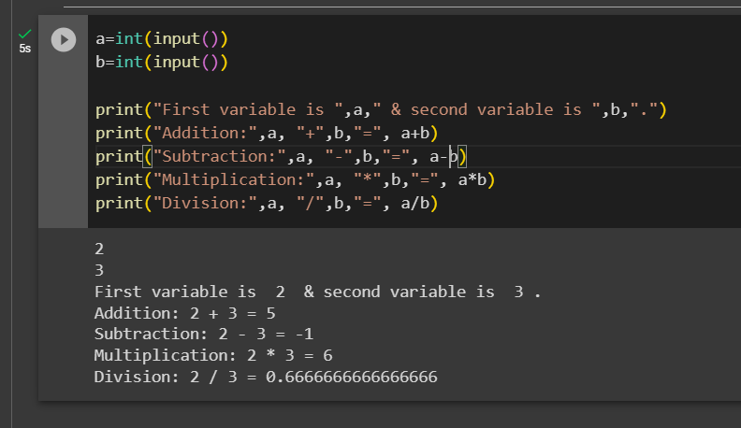

Q.2. What is the difference between the following operators:

(i) ‘/’ & ‘//’

/ is point(true) division- returns whatever value we obtain as a result of the operation, // is floor division- it will return only the integer part of whatever we receive after the operation

(ii) ‘**’ & ‘^’

** is the exponent operator, eg: 2**3=8, and ^ is the XOR operator, it sets each bit to 1 if only one of the two bits is 1. Eg 5^1 is (0101)^ (0001)= (0100)=4

Q.3. List the logical operators.

3 logical operators- not (returns the negation of the operand to which it is applied), and (returns true only if both of the statements are true), or (Returns true if any one of the statement is true,otherwise false)

Q.4. Explain right shift operator and left shift operator with examples.

Python bitwise left shift operator shifts the left operand bits towards the left side for the given number of times in the right operand. In simple terms, the binary number is appended with 0s at the end.

Python right shift operator is exactly the opposite of the left shift operator. Then left side operand bits are moved towards the right side for the given number of times. In simple terms, the right side bits are removed.

Q.5. Create a list containing int type data of length 15. Then write a code to check if 10 is

present in the list or not.

